3GPP TSG RAN WG1 #125 R1-2604232
Dalian, China, May. 18th ~ 22th, 2026
Agenda Item: 10.8.3
Source: Lenovo
Title: Views on waveform and frame structure for ISAC
Document for: Discussion and decision

Introduction
A new Study Item (SI) on 6G Radio was approved in RAN#108 [1], where the study on sensing was agreed with a wide scope of potentially supporting different sensing modes, use-cases/target types, as well as sensing-specific adjustment/optimization of radio signals and procedures.
In RAN1#124-bis meeting, initial agreements have been made on the choice of OFDM-based waveform processing as starting point for study and further evaluations. Furthermore, the scope for next-step discussions is identified as following [4]: Based on the agreements made in RAN1#124-bis, the following topics will be prioritized for discussion in RAN1#125-bis.
- Identification of potential enhancements to be applied for CP-OFDM waveform for 6G ISAC, including:
  - Necessity/Expected benefit of enhancement compared to 6GR CP-OFDM for communication
  - Applicable scenarios and sensing modes
- Necessity and potential benefits of specifying a waveform for:
  - TRP-TRP bistatic sensing
  - TRP monostatic
  - UE monostatic
- Identification of potential enhancements to be applied for 6GR frame structure for 6G ISAC, including:
  - Necessity/Expected benefit of enhancement compared to 6GR frame structure for communication
  - Applicable scenarios and sensing modes
- Evaluation method of enhancements to be applied for waveform and/or frame structure for 6G ISAC
  - Necessity/pros/cons/metrics of LLS and/or SLS
  - Pros/cons/metrics of theoretical waveform characteristics analysis
- Identification of new waveforms for 6G ISAC, which is different from 6GR CP-OFDM for communication
  - Necessity/Expected benefit of enhancement compared to 6GR CP-OFDM for communication
  - Applicable scenarios and sensing modes
In this contribution, we share our views on the above-outlined main issues under discussion for ISAC-specific waveform and frame-structure aspects.

Waveform

General views
In RAN1#124-bis, it has been agreed that CP-OFDM waveform processing to be a starting point of further potential enhancements, as well as a benchmark for study of other waveform proposals [Appendix A, Agreements#1,#4]. In order to analyses suitability of an enhancement or a new waveform proposal, several KPI metrics are envisioned. An example set of metrics has been initially proposed as following

FL Proposal 6.1.4 [3]
If 6G ISAC waveform characteristics analysis is used for evaluation, at least the following metrics are used for waveform evaluation.
- PAPR
- Ambiguity function main lobe width
- Ambiguity function PSLR (Peak-to-Side Lobe Ratio)/ISLR (Integrated Side Lobe Ratio)
- Auto/cross-correlation property
- Waveform confinement and emission compliance
- Self-interference resilience
- OOBE (Out-Of-Band Emission)/ACLR (Adjacent Channel Leakage Ratio)
- Multiplexing capability
- MRSS, MIMO support

Moreover, it is observed that the methodology for evaluating a waveform feature may include analyzing fundamental waveform characteristics (e.g., PAPR, auto/cross-correlation behavior), as well as evaluating the resulting performance in a link or a system level evaluation scenario. To this end, companies are encouraged to provide analysis of the suggested evaluation methodology for ISAC waveform, including fundamental waveform characteristics, LLS, and SLS [Appendix A, Agreement#3].
In this respect, we would like to point out that the metrics inferred from the fundamental waveform characteristics are not directly transferable from the literature of radar systems to the class of OFDM-based radar processing, due to few differences.
Firstly, the fundamental signal correlation and/or ambiguity function behavior, is highly matched to the correlation-based radar receivers operated in analog/time domain. Nevertheless, the OFDM-based receiver performs an FFT-based processing and performs the sensing measurements in the post-OFDM demodulation stage. From this perspective, the perceived metrics of auto-correlation and cross-correlation deviate from the fundamental waveform characteristics defined via radar theory and become dependent, at least in part, on the receiver processing strategy.
Secondly, while merit of each of the above metrics can be individually justified, they generally behave as competing/conflicting objectives in a joint optimization setting for a multi-objective problem, e.g., enhancing the main lobe behavior leads to a degraded sidelobe and/or PAPR performance. As such, while analyzing one or multiple stand-alone metrics can be informative for understanding the waveform behavior, at least LLS would be necessary to evaluate the impact of a waveform candidate and/or enhancement feature, jointly incorporating the impact of the target channel, background channel, Rx processing logic, as well as the waveform behavior.
Observation 1. perceived metrics of auto-correlation and cross-correlation deviate from the theoretical definitions of waveform characteristics for OFDM-based Rx processing and become dependent on the receiver processing strategy.
Observation 2. Several envisioned metrics for waveform analysis act as conflicting objectives. As such, the end-to-end performance may not be inferred from one or a small subset of the metrics listed in FL Proposal 6.1.4 [3].
- At least LLS would be necessary to evaluate the impact of a waveform candidate and/or enhancement feature, jointly incorporating the impact on the target channel, background channel, Rx processing logic.
For the scenarios wherein the sensing Tx and Rx devices enjoy harmonized implementation, e.g., when UEs and/or TRPs belonging to the same vendor or operate in monostatic sensing modes, the implementation-based waveform could be considered with some reserved radio resources if needed. For example, a number of dedicated OFDM symbols or a subframe can be reserved for the sensing signal transmission and receiving, though it could have some impacts on the data scheduling restriction for communication.
- Study the feasibility and necessity of implementation-based waveforms with reserved radio resources for some sensing modes, e.g., TRP-TRP bistatic sensing, TRP monostatic and UE monostatic modes.

Pulse-Wave (PW) signal
Note that the Pulse-Wave (PW)-like and Continuous-Wave (CW)-like sensing signals have been proposed as sensing signal candidates for the TRP mono-static and bi-static sensing modes. In particular, the PW signal has the potential to utilize delay differences of the sensing path and the direct or leakage path (containing prohibitively large energy), in order to separate the signal reception in the time domain, thereby counteracting the limited dynamic range challenge at the sensing Rx node. An example operation for PW and CW sensing signal for monostatic sensing mode is illustrated in Figure 1.
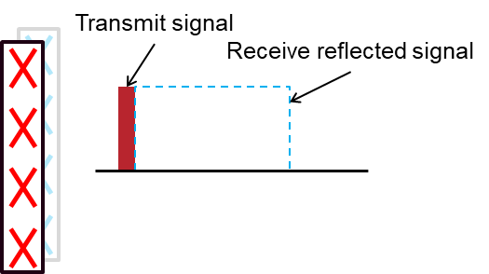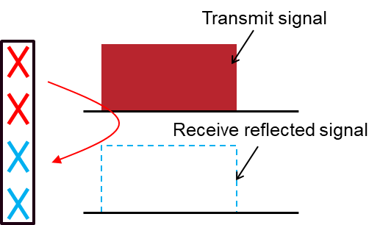
Figure 1 PW and CW sensing signals for mono-static sensing
For the PW-signal, all antennas can be used to transmit and receive the signals, which means potentially larger transmission power, higher beamforming gain, smaller spatial domain resolution and larger range detected, though there would be a ‘deaf’ period/range for the signal transmission and Tx-Rx switching time.
For the CW-signal, there would not be a ‘deaf’ period/range due to the simultaneous transmitting and receiving signals with the isolated antennas, which means the less transmission power to avoid interference, lower beamforming gain, larger spatial domain resolution and smaller range detected.
Therefore, both kinds of signals have pros and cons for sensing and can be potentially applied in different scenarios and sensing modes. Furthermore, the PW signals can be potentially used as sensing signal, in addition to the monostatic sensing modes, in the bistatic modes impaired due to the LOS path dynamic range, and wherein the propagation delay of the sensing target path exceeds that of the direct path with a large margin.
- Study the feasibility of PW-like and CW-like signals in different scenarios.
As we propose above, the CW-like signal can be generated by the waveform used for communication, i.e., CP-OFDM or DFT-s-OFDM in general. It is necessary to envision the PW-signal generation separately, especially when the sensing signal is generated at a same or different symbols as the co-existing data transmissions or other reference signals.
When the sensing signal is transmitted within a dedicated resource/symbol, the pulse-signal can be shaped in time domain via implementation according to a time-domain pulse-shape, where the pulse width and off-periods can be adjusted to the sensing scenario, e.g., the expected target path and direct path delays and pathloss.
- Study the PW-like sensing signals, including generation, parameterization and evaluation, in different scenarios, radio capabilities and waveform numerology.
On the other hand, when the sensing signal is intended to co-exist with communication or other RS transmissions within the same symbol, the pulse-shape signal shall be generated as part of the waveform processing used for communication. As such, it is motivated to study the pulse-shape generation compliant with OFDM waveform processing, wherein the communication and sensing resources are multiplexed within the same symbol. One example implementation is depicted in Figure 2 below.
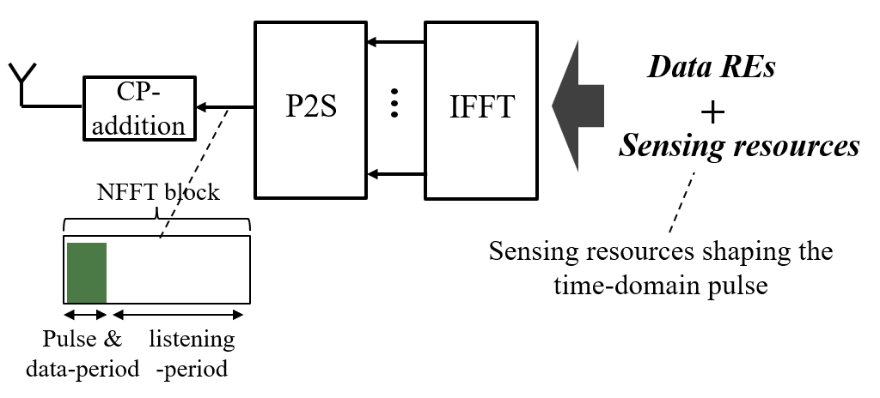
Figure 2 An illustration of pulse-wave signal shaping and shared with communication data in the same OFDM symbol based on IFFT processing
In this scheme, the pulse-wave signal is shaped and shared with communication data within an OFDM via IFFT, which benefits for the co-existence with communication.
Therefore, no single signal structure is optimal across all sensing scenarios and modes, motivating flexible OFDM compliant PW-like and CW-like realizations over a pure OFDM baseline.
- Study the PW-like signal generation, considering the efficient coexistence with communication transmission within the same symbol, via IFFT processing.

Frame structure

Numerologies
Due to the different assumptions on the sensing signal Tx and Rx selection, the signal propagation and processing, e.g., mono-static sensing and TRP-TRP bi-static sensing, could be different with communication for the potential larger propagation delay and delay spread.
Moreover, the sensing target may be envisioned with a large speed, leading to a high doppler shift, which may occur separately or together with the large propagation delay for remote targets, e.g., a UAV at a high altitude and high speed, leading to a target path jointly showing a large propagation delay and doppler shift at the receiver. While the high doppler facilitates more efficient signal processing via doppler processing, e.g., reduced need to large sensing time-window, it negatively impacts the per-symbol reading of the received signal when the doppler shift is not negligible compared to subcarrier spacing (SCS).
Thus, it is necessary to consider methods to adjust the SCS and CP length for sensing signals, considering scenario-specific requirements. Note that extended CP has been concluded to not be further studied for TN communication in RAN1#123, however the necessity for sensing should be studied, for all sensing modes in different deployment scenarios, for the different signal propagation and processing assumptions.
- Study the necessity and efficient methods for extending CP (i.e., longer CP than the normal CP for communication) and larger SCS (with shorter OFDM symbol) for sensing signals.
In order to facilitate a flexible CP expansion framework while jointly improving resilience to doppler impairments at the receiver, an OFDM-based sensing signal can be shaped to show sub-symbol periodicity, by restricting the non-zero input subcarriers to the IFFT block at certain locations. This can be realized by following a comb-C structure including the DC subcarrier, leading to the sub-symbol repetition in time-domain of N/C, with N being the NFFT length. An example such property of a sensing symbol is depicted in the below Figure 3.
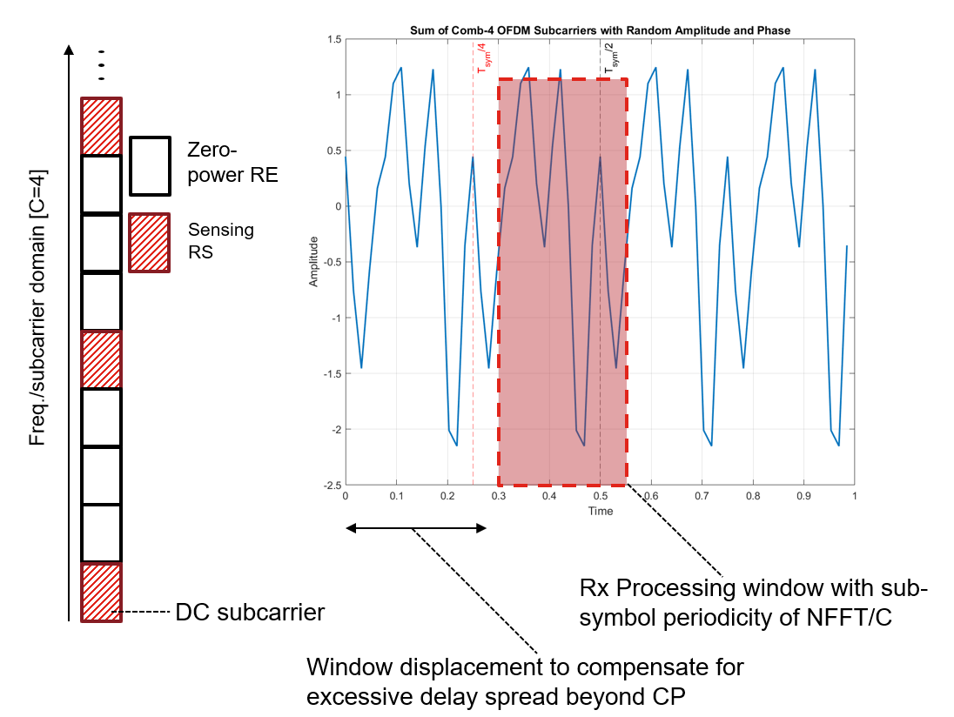
Figure 3 An illustration of sub-symbol periodicity, based on comb C=4 structure for a symbol carrying sensing signal.
Please note that with the above, two challenges are addressed at the same time. Firstly, a larger effective CP is generated by adjusting the Rx processing window to the expected maximum delay of the sensing paths, utilizing the produced sub-symbol periodicity, i.e., due to the sub-symbol periodicity, without inserting larger CP in the frame structure, thereby avoiding the energy loss with larger CP. Secondly, a higher doppler resilience is achieved by allowing multiple short measurement window sizes, i.e., N/C, for which the cyclic property is preserved.
- RAN1 to consider OFDM-based sensing signal generation with intra-symbol cyclic property to achieve larger CP behavior.

Radio resource multiplexing
In general, the radio resources for communication and sensing can be the same; orthogonally multiplexed in time domain (TDM), frequency domain (FDM) or spatial domain (SDM); or be superimposed in a radio frame. The sensing signals receiver can process the sensing signals from the configured resources to derive the measurement results as illustrated in Figure .
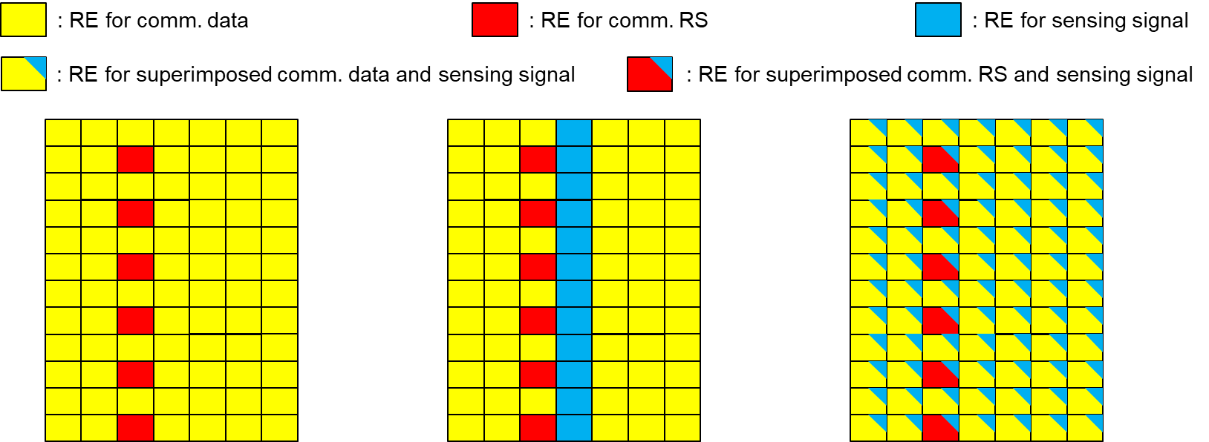
Alt.1: Same for both Alt.2: Orthogonal Alt.3: Superimposed
Figure 4. Illustration of example radio resources allocations for communication and sensing, potentially including superimposed sensing signal with communication signals
In many sensing scenarios relying on a high-accuracy Doppler estimation and filtering, a larger sensing interval is needed. Consequently, a large sensing coherent processing interval also leads to a large per-task sensing overhead, e.g., in terms of the total sensing REs resources consumed, while leading to a large SNR boost due to the coherent combining.
In one example scenario, for an always-on signal with Fc = 6GHz and BW = 100MHz, SCS= 30kHz, for sensing of a human movement with 3km/h speed, a sensing time duration of 300 msec is needed to reach speed resolution equivalent to 10% of the typical human speed. Subsequently, this leads to 72-75dB of coherent processing gain, assuming an always-on signal at all available REs.
The above example motivates the use of low-power sensing signal, superimposed with the communication signals and/or other RSs in the power domain without orthogonality restrictions. In such a case, sensing processing relies on the large coherence gain over the sensing time window to recover the needed sensing signal strength, while remaining harmless to the superimposed communication resources, due to the substantially lower power.
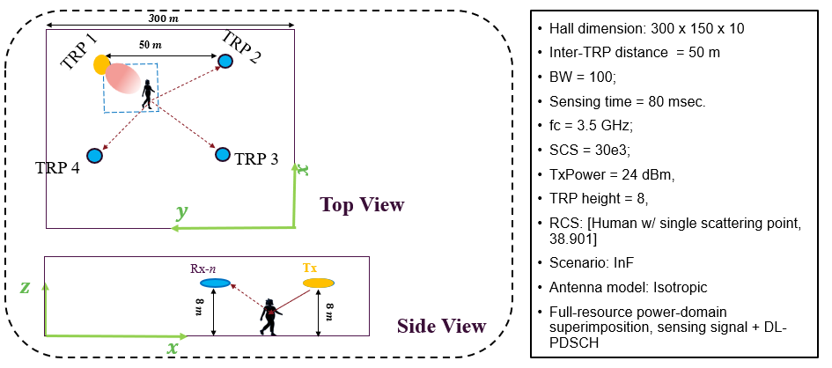
Figure 5 An example scenario for sensing signal superimposition, DL PDSCH superimposed in power domain with sensing signal across all allocated REs.
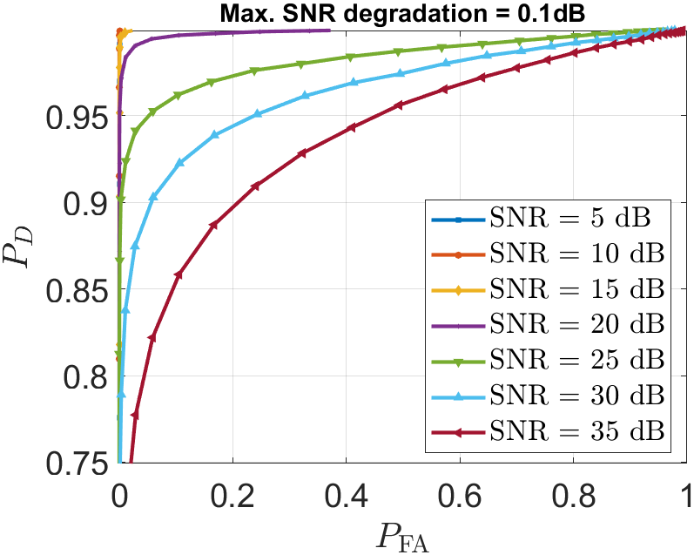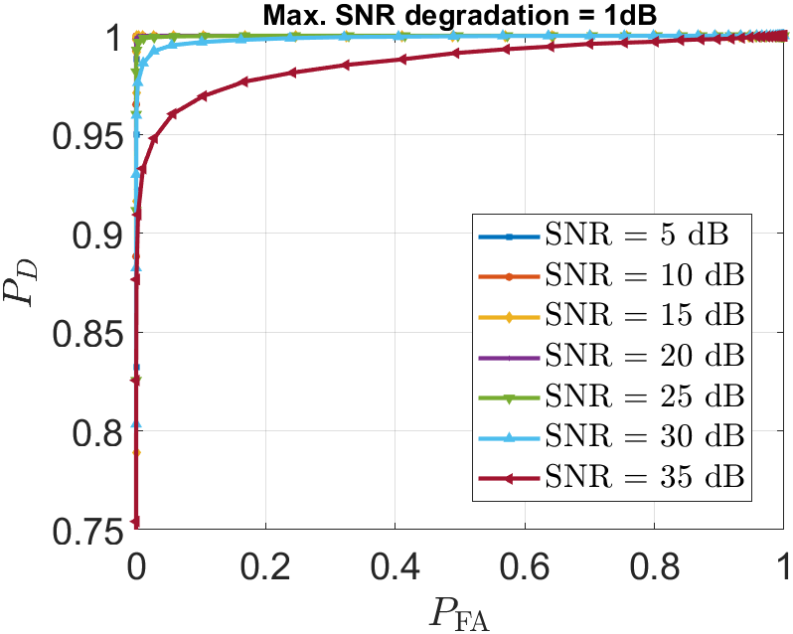
Figure 6 An example scenario for sensing signal superimposition, DL PDSCH superimposed in power domain with sensing signal across all allocated REs. The sensing signal power is limited, for a given link SNR, such that the experienced link SNR is not degraded above a Max SNR degradation level.

In Figure 6, an example scenario for power-domain sensing signal superimposition is depicted, wherein the sensing signal is added to the DL PDSCH signal without (time/freq./code) orthogonality limitation. A selected TRP performs sensing Rx measurements in LOS condition to the target, assuming a perfect clutter suppression at the receiver. Moreover, it is considered that the sensing signal power is limited according to a PDSCH link SNR and a given maximum SNR degradation. For instance, for a Tx power of 24 dBm, when a scheduled PDSCH link enjoys SNR = 10 dB, then the allowed transmission power of the sensing signal is 8.1 dBm, for a maximum tolerable SNR degradation of 1 dB, and -2.3 dBm for a maximum tolerable SNR degradation of 0.1 dB. Please note that, the substantially reduced transmission power is compensated, given the scenario with relatively short distances, as well as the long sensing time (leading to a large coherence combining gain at the sensing receiver), recovering sensing performance to an acceptable level.
The feasibility and optimal strategy for sensing signal superimposition can be use-case and scenario dependent, with potentially larger gain with scenarios with lower mobility and targets with larger RCS. As such, it is motivated to study feasibility and methods to facilitate power domain superimposed sensing transmission to reduce time/frequency resource overhead for sensing.
Please note that due to the negligible power of the superimposed sensing signal, the data receiver treats the received sensing signal as part of the receiver noise floor, with negligible impact on the perceived link SNR, as exemplified in Figure 6 above. As such, the waveform for the superimposed sensing signal can be chosen with higher freedom regarding coexistence requirements (e.g., ACLR and OOB emissions), as well as compliance with the waveform used for the co-existing data transmission, e.g., the sensing waveform may be chosen differently or with a different numerology as the co-existing data transmission.
Observation 3.. At least for a subset of sensing scenarios and target types, the sensing signal can be superimposed with the transmitted data in power domain, and treated as negligible noise by the data receiver
Proposal 8. RAN1 to study the waveform and numerology for superimposed sensing signal with relaxed requirements on co-existence and compliance with the superimposed communication signal

Conclusion
The main proposals within this document are summarized following:
Observation 1. perceived metrics of auto-correlation and cross-correlation deviate from the theoretical definitions of waveform characteristics for OFDM-based Rx processing and become dependent on the receiver processing strategy.
Observation 2. Several envisioned metrics for waveform analysis act as conflicting objectives. As such, the end-to-end performance may not be inferred from one or a small subset of the metrics listed in FL Proposal 6.1.4 [3].
- At least LLS would be necessary to evaluate the impact of a waveform candidate and/or enhancement feature, jointly incorporating the impact on the target channel, background channel, Rx processing logic.
- Study the feasibility and necessity of implementation-based waveforms with reserved radio resources for some sensing modes, e.g., TRP-TRP bistatic sensing, TRP monostatic and UE monostatic modes.
- Study the feasibility of PW-like and CW-like signals in different scenarios.
- Study the PW-like sensing signals, including generation, parameterization and evaluation, in different scenarios, radio capabilities and waveform numerology.
- Study the PW-like signal generation, considering the efficient coexistence with communication transmission within the same symbol, via IFFT processing.
- Study the necessity and efficient methods for extending CP (i.e., longer CP than the normal CP for communication) and larger SCS (with shorter OFDM symbol) for sensing signals.
- RAN1 to consider OFDM-based sensing signal generation with intra-symbol cyclic property to achieve larger CP behavior.
Observation 3.. At least for a subset of sensing scenarios and target types, the sensing signal can be superimposed with the transmitted data in power domain, and treated as negligible noise by the data receiver
Proposal 8. RAN1 to study the waveform and numerology for superimposed sensing signal with relaxed requirements on co-existence and compliance with the superimposed communication signal

References
- RP-251881, NTT DOCOMO (Moderator), “New SID: Study on 6G Radio”, 3GPP TSG RAN Meeting #108, Prague, Czech Republic, June 9-13, 2025
- R1-2602834, Lenovo, “On the aspects of communication and sensing integration”, 3GPP TSG RAN WG1 #124bis, Malta, MT, Apri.13th ~ 17th, 2026
- R1-2602985, Summary on Waveform and frame structure for 6G ISAC, 3GPP TSG RAN WG1 #124-bis - Malta, Apr. 13th ~ 17th, 2026.

Appendix A – Agreements

Agreement #1:
CP-OFDM waveform as defined for 6GR is the starting point for 6G ISAC waveform study.
Study on enhancements on CP-OFDM or other waveforms is not precluded.
Agreement #2:
6GR communication frame structure is the starting point for 6G ISAC frame structure study, in at least the following aspects.
- Frame/sub-frame/slot/symbol structure
- CP length
- SCS
Enhancements on frame structure/above aspects are not precluded.
Agreement #3:
Companies are encouraged to provide views on necessity/pros/cons/metrics of LLS and/or SLS and pros/cons/metrics of theoretical waveform characteristics analysis, for evaluation of ISAC waveform and/or integration with communication, to RAN1#125 meeting.
Agreement #4:
CP-OFDM is used as the benchmark for evaluating the benefits of sensing waveforms.

